Please see below for more information on Rick’s fund for ongoing treatment and medications for a kidney transplant. As Rick is now back on track for the transplant, we are helping to cover the medications necessary following the transplant.
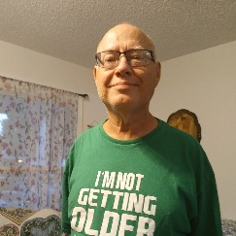
Rickey G Turner
Garland, TX
South-Central Transplant Fund
Help Hope Live for Rickey Turner
Rick is 66 years old. He was diagnosed over 5 years ago with end stage renal failure. He began having dialysis 3 times a week immediately. He has been doing well by eating the right foods, taking his meds and faithfully attending his 4 hour dialysis sessions . He was approved to be on the list for a kidney transplant and has been waiting over 5 years as he is O negative blood type.
Rick loves to read and look at videos on his phone and go on walks. He is a very quiet person who keeps to himself most of the time. When he decides to be social he is so interesting. He is like an encyclopedia.
Donate Online:
https://helphopelive.org/donate-to-campaign/?id=26283
Mail a Check:
Make checks payable to:
Help Hope Live
Note in memo:
In honor of Rickey G Turner
Mail to:
Help Hope Live
2 Radnor Corporate Center
Suite 100
100 Matsonford Road
Radnor, PA 19087
Donor preference is important to us. Please specify in writing if you wish for your name or donation amount to be kept private.

